Minutes of Village Hall meeting Thursday 14th July at 7:30pm
In attendance: F Gunn-Stokes, K Stuart, T Thompson, A Taylor, A Bott, R Miller,
- Minutes of 27th to be agreed next meeting as FGS had problem with computer and couldn’t circulate them .
Action: FGS to bring to next meeting in September
- Apologises accepted from R Bailey and C Sellers
- Update on events and other news (FGS)
May Day reunion and Jubilee events well attended and enjoyed by the community.
Proposed events agreed:
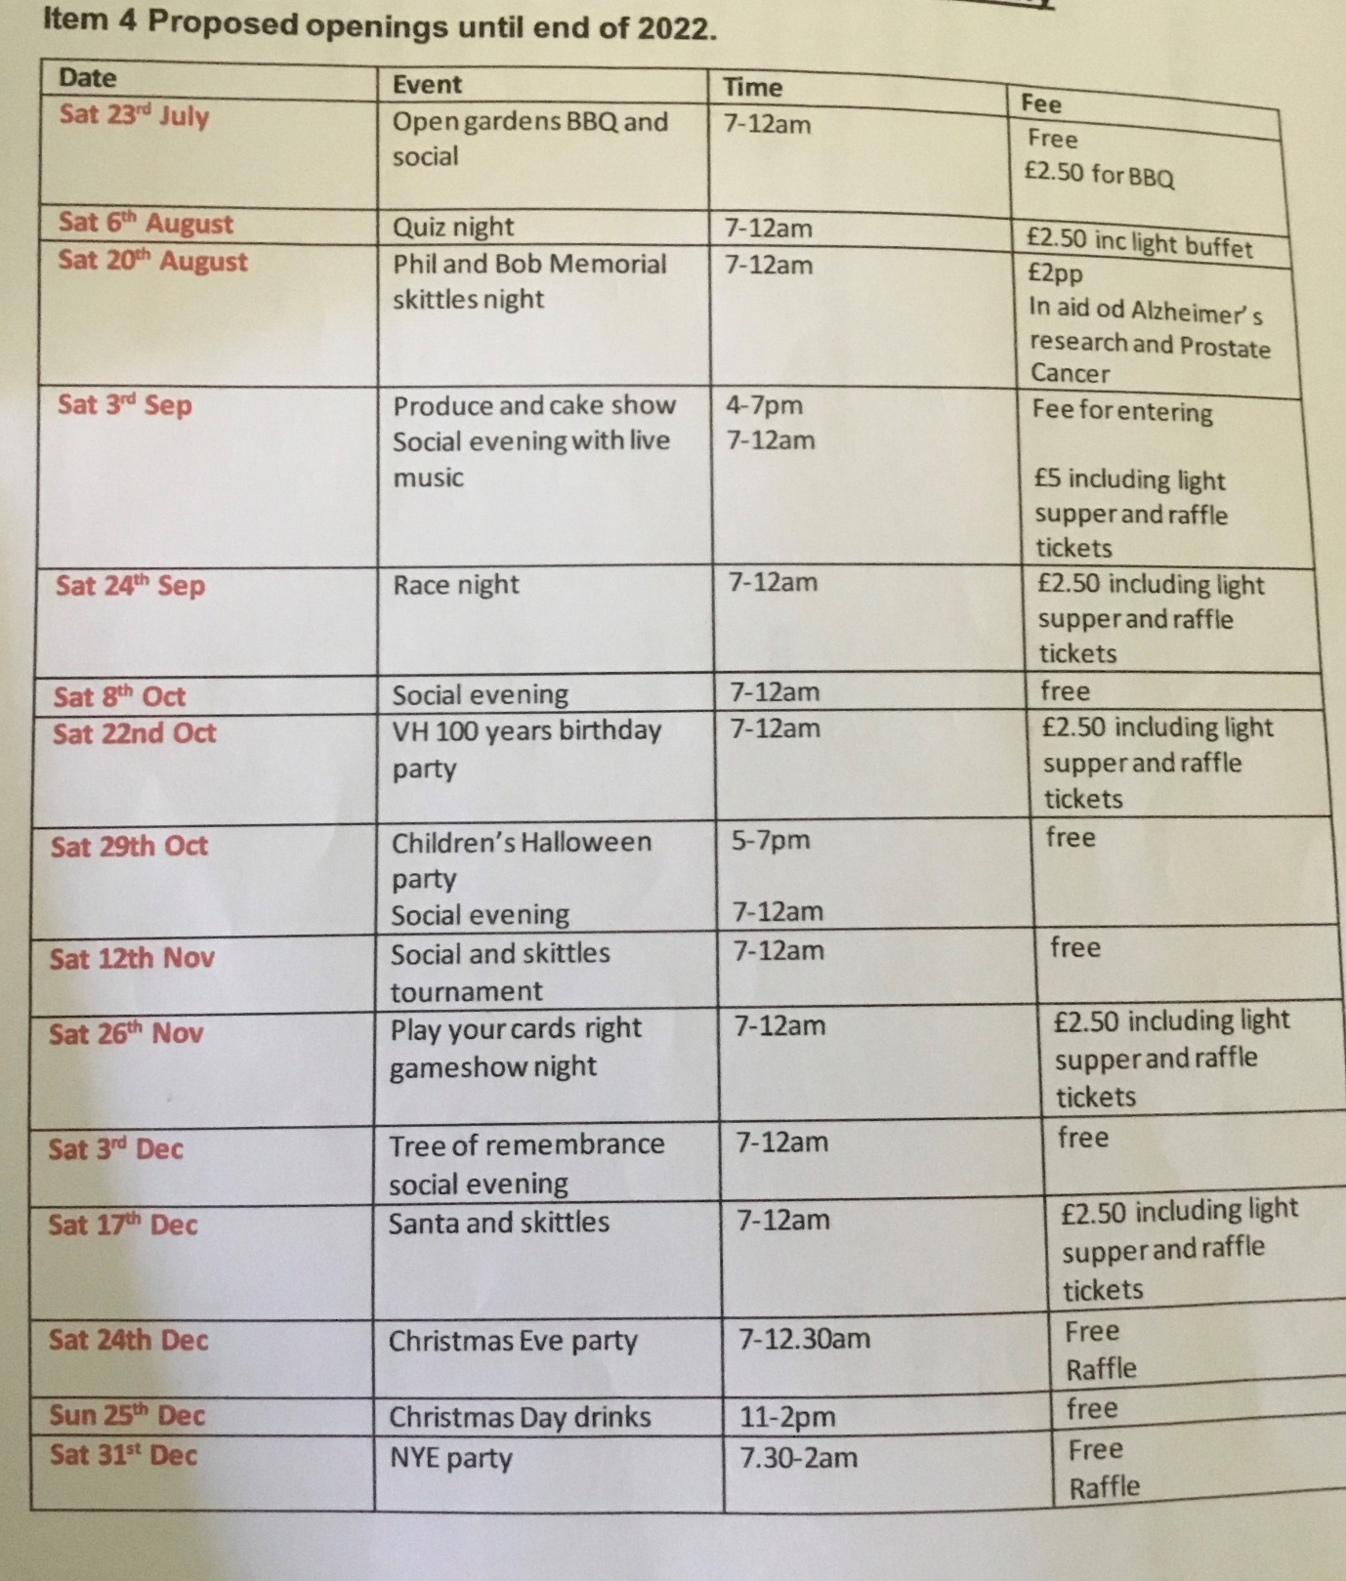

4.KS presented financial update (attached)
Windfarm have granted CAVH £5000 and agreed to be spent on electrics following EICR report in May. Michael O’Sullivan to carry out Installation and supply of new mains cabling to bar area including new distribution board and rewire of existing circuits. (price £4000) Remaining £1000 to be spent on hot water system in toilets and electric hand dryers.
Action KS to arrange date with MS and source dryers and hot water system

5.Luncheon club Deferrred to next meeting as CS not present

